Mark Wagner

Lab 6

SDEV300-7983

4/25/2019

SQL STATEMENTS

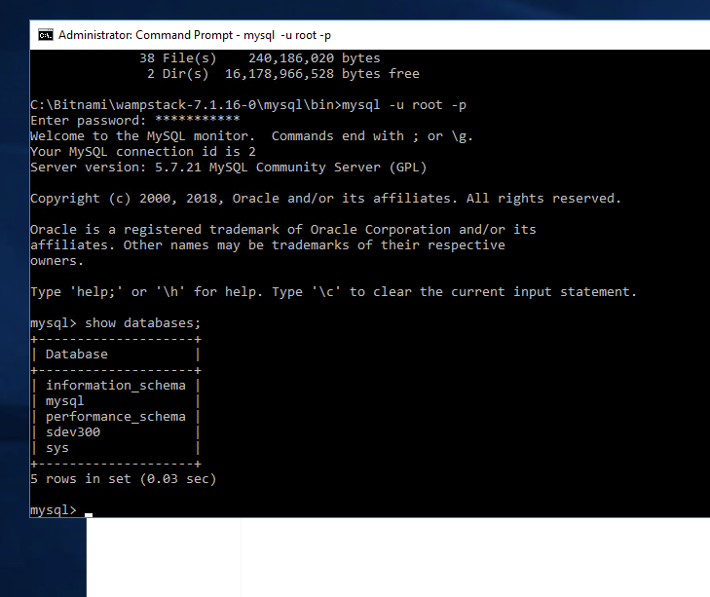

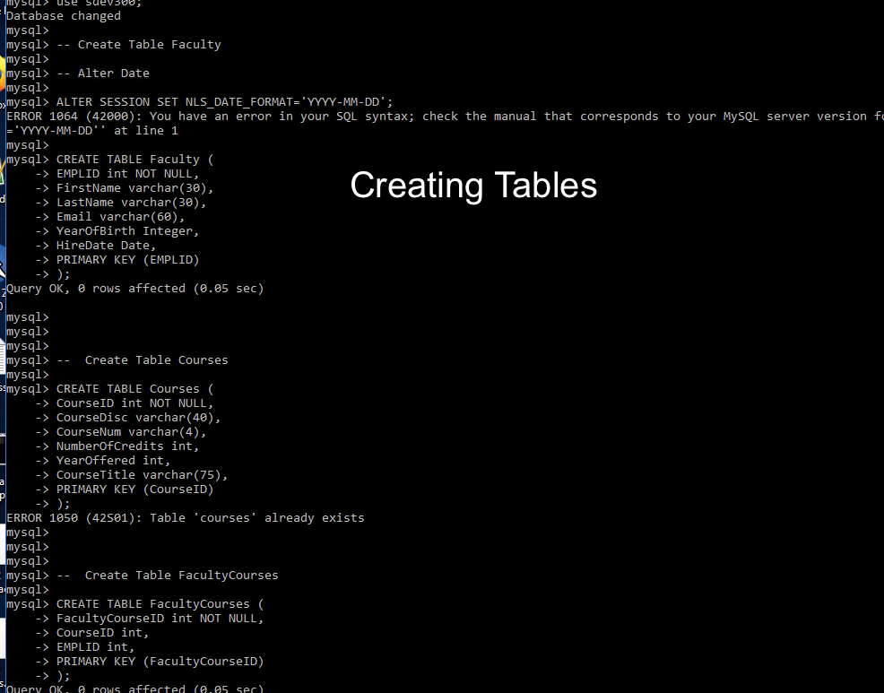

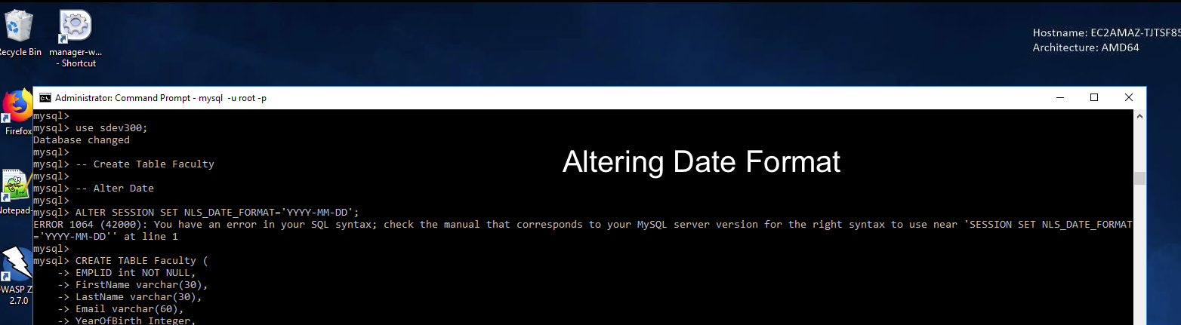

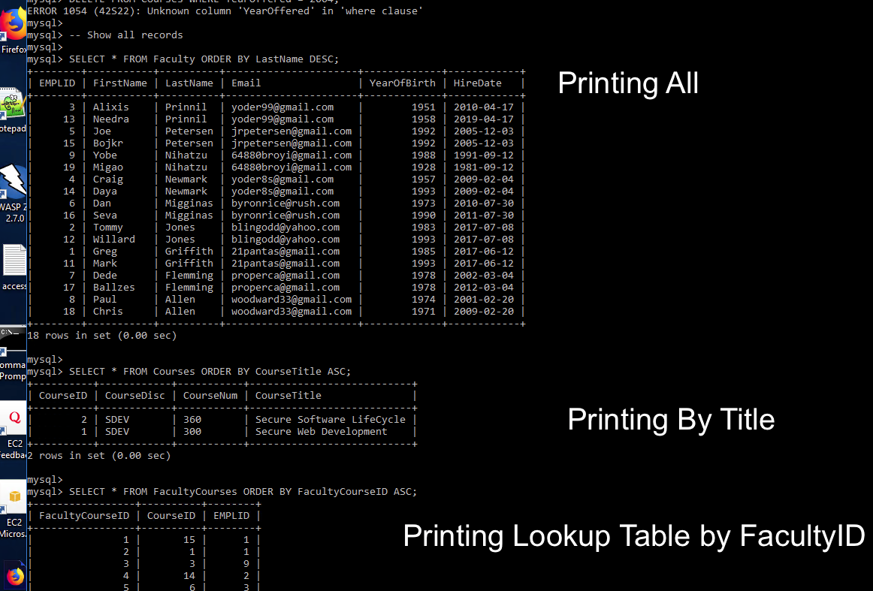

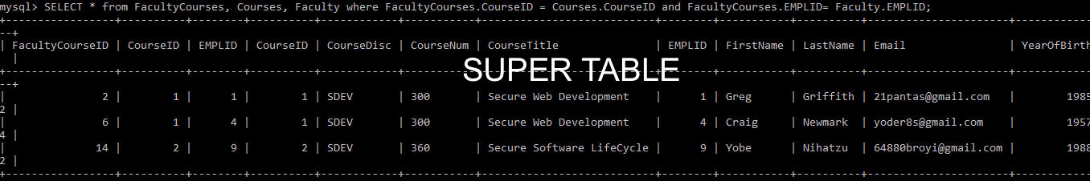

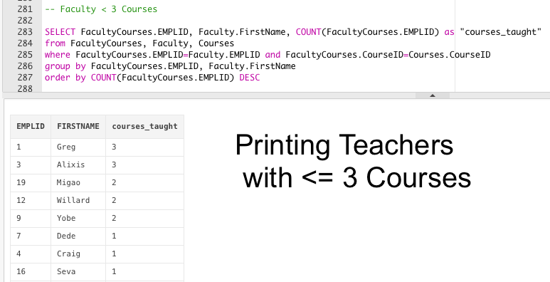

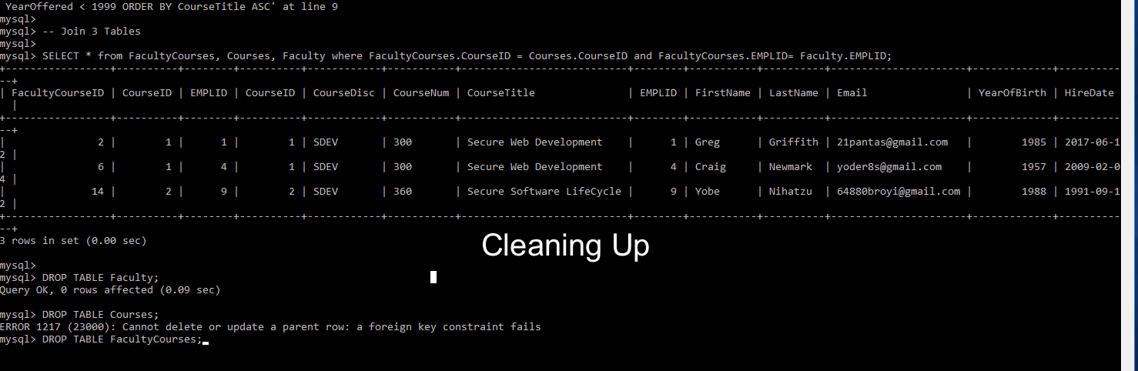

SPOOL FILE:

Statement processed. Table created. Table created. Table created. 1 row(s) inserted. 1 row(s) inserted. 1 row(s) inserted. 1 row(s) inserted. 1 row(s) inserted. 1 row(s) inserted. 1 row(s) inserted. 1 row(s) inserted. 1 row(s) inserted. 1 row(s) inserted. 1 row(s) inserted. 1 row(s) inserted. 1 row(s) inserted. 1 row(s) inserted. 1 row(s) inserted. 1 row(s) inserted. 1 row(s) inserted. 1 row(s) inserted. 1 row(s) inserted. 1 row(s) inserted. 1 row(s) inserted. 1 row(s) inserted. 1 row(s) inserted. 1 row(s) inserted. 1 row(s) inserted. 1 row(s) inserted. 1 row(s) inserted. 1 row(s) inserted. 1 row(s) inserted. 1 row(s) inserted. 1 row(s) inserted. 1 row(s) inserted. 1 row(s) inserted. 1 row(s) inserted. 1 row(s) inserted. 1 row(s) inserted. 1 row(s) inserted. 1 row(s) inserted. 1 row(s) inserted. 1 row(s) inserted. 1 row(s) inserted. 1 row(s) inserted. 1 row(s) inserted. 1 row(s) inserted. 1 row(s) inserted. 1 row(s) inserted. 1 row(s) inserted. 1 row(s) inserted. 1 row(s) inserted. 1 row(s) inserted. 1 row(s) inserted. 1 row(s) inserted. 1 row(s) inserted. 1 row(s) inserted. 1 row(s) inserted. 1 row(s) inserted. 1 row(s) inserted. 1 row(s) inserted. 1 row(s) inserted. 1 row(s) inserted. 1 row(s) inserted. 1 row(s) inserted. 1 row(s) inserted. 1 row(s) inserted. 1 row(s) inserted. 20 row(s) updated. 0 row(s) updated. 2 row(s) deleted. 2 row(s) deleted.

Result Set 1

|  |  |  |  |  |  |
| --- | --- | --- | --- | --- | --- |
| **EMPLID** | **FIRSTNAME** | **LASTNAME** | **EMAIL** | **YEAROFBIRTH** | **HIREDATE** |
| 13 | Needra | Prinnil | yoder99@gmail.com | 1958 | 2019-04-17 |
| 3 | Alixis | Prinnil | yoder99@gmail.com | 1951 | 2010-04-17 |
| 5 | Joe | Petersen | jrpetersen@gmail.com | 1992 | 2005-12-03 |
| 15 | Bojkr | Petersen | jrpetersen@gmail.com | 1992 | 2005-12-03 |
| 9 | Yobe | Nihatzu | 64880broyi@gmail.com | 1988 | 1991-09-12 |
| 19 | Migao | Nihatzu | 64880broyi@gmail.com | 1928 | 1981-09-12 |
| 14 | Daya | Newmark | yoder8s@gmail.com | 1993 | 2009-02-04 |
| 4 | Craig | Newmark | yoder8s@gmail.com | 1957 | 2009-02-04 |
| 16 | Seva | Migginas | byronrice@rush.com | 1990 | 2011-07-30 |
| 6 | Dan | Migginas | byronrice@rush.com | 1973 | 2010-07-30 |
| 12 | Willard | Jones | blingodd@yahoo.com | 1993 | 2017-07-08 |
| 2 | Tommy | Jones | blingodd@yahoo.com | 1983 | 2017-07-08 |
| 1 | Greg | Griffith | 21pantas@gmail.com | 1985 | 2017-06-12 |
| 11 | Mark | Griffith | 21pantas@gmail.com | 1993 | 2017-06-12 |
| 7 | Dede | Flemming | properca@gmail.com | 1978 | 2002-03-04 |
| 17 | Ballzes | Flemming | properca@gmail.com | 1978 | 2012-03-04 |
| 8 | Paul | Allen | woodward33@gmail.com | 1974 | 2001-02-20 |
| 18 | Chris | Allen | woodward33@gmail.com | 1971 | 2009-02-20 |

[Download CSV](https://livesql.oracle.com/apex/f?p=590:1:103334344504251::NO:93::&success_msg=MyBkYXRhYmFzZSBvYmplY3RzIGhhdmUgYmVlbiBkcm9wcGVkLiAgU2Vzc2lvbiBo.,aXN0b3J5IGhhcyBiZWVuIHJlbW92ZWQuIE5MUyBzZXR0aW5ncyByZXNldC4~%2FPZPqYqSv_0S-Pd3VixiYwshbPj6hCdVPRW8_7p-wgMkKdkiuyNkCAUtUw5w71jRBlpGDzhbtL_GrbgHZADLIlg)  
18 rows selected.

Result Set 2

|  |  |  |  |  |  |
| --- | --- | --- | --- | --- | --- |
| **COURSEID** | **COURSEDISC** | **COURSENUM** | **NUMBEROFCREDITS** | **YEAROFFERED** | **COURSETITLE** |
| 20 | PRDD | 131 | 6 | 2003 | Advanced SAP |
| 4 | CMSC | 343 | 6 | 2001 | Binary |
| 17 | CMSC | 409 | 6 | 2012 | Build A Modem |
| 1 | SDEV | 300 | 6 | 1996 | Building Secure Web Applications |
| 12 | CMSC | 422 | 6 | 1974 | C++ |
| 3 | MATH | 301 | 6 | 1995 | Calc |
| 5 | BUSN | 151 | 6 | 1998 | Finance |
| 8 | MATH | 301 | 6 | 2017 | Geometry |
| 7 | CMSC | 485 | 6 | 2013 | Into to Computer Science |
| 9 | CMSC | 373 | 6 | 2007 | Java |
| 10 | BUSN | 191 | 6 | 2019 | M&A |
| 16 | CMIS | 300 | 6 | 2000 | MS Dos |
| 15 | MMTT | 111 | 6 | 2003 | Money Making Essentials |
| 18 | CMIS | 325 | 6 | 2009 | Production Teams |
| 2 | CMSC | 495 | 6 | 1992 | Puzzles |
| 6 | SDEV | 360 | 6 | 2008 | Servers |
| 13 | MATH | 302 | 6 | 1992 | Statistics |
| 11 | SDEV | 307 | 6 | 2010 | Web Applications II |

[Download CSV](https://livesql.oracle.com/apex/f?p=590:1:103334344504251::NO:93::&success_msg=MyBkYXRhYmFzZSBvYmplY3RzIGhhdmUgYmVlbiBkcm9wcGVkLiAgU2Vzc2lvbiBo.,aXN0b3J5IGhhcyBiZWVuIHJlbW92ZWQuIE5MUyBzZXR0aW5ncyByZXNldC4~%2FPZPqYqSv_0S-Pd3VixiYwshbPj6hCdVPRW8_7p-wgMkKdkiuyNkCAUtUw5w71jRBlpGDzhbtL_GrbgHZADLIlg)  
18 rows selected.

Result Set 3

|  |  |  |
| --- | --- | --- |
| **FACULTYCOURSEID** | **COURSEID** | **EMPLID** |
| 1 | 15 | 1 |
| 2 | 1 | 1 |
| 3 | 3 | 9 |
| 4 | 14 | 2 |
| 5 | 6 | 3 |
| 6 | 1 | 4 |
| 7 | 6 | 5 |
| 8 | 2 | 10 |
| 9 | 16 | 10 |
| 10 | 8 | 16 |
| 11 | 7 | 7 |
| 12 | 19 | 18 |
| 13 | 12 | 19 |
| 14 | 2 | 9 |
| 15 | 14 | 16 |
| 16 | 3 | 3 |
| 17 | 9 | 10 |
| 18 | 8 | 12 |
| 19 | 14 | 17 |
| 20 | 3 | 15 |
| 21 | 16 | 12 |
| 22 | 4 | 3 |
| 23 | 15 | 6 |
| 24 | 13 | 19 |
| 25 | 10 | 1 |

[Download CSV](https://livesql.oracle.com/apex/f?p=590:1:103334344504251::NO:93::&success_msg=MyBkYXRhYmFzZSBvYmplY3RzIGhhdmUgYmVlbiBkcm9wcGVkLiAgU2Vzc2lvbiBo.,aXN0b3J5IGhhcyBiZWVuIHJlbW92ZWQuIE5MUyBzZXR0aW5ncyByZXNldC4~%2FPZPqYqSv_0S-Pd3VixiYwshbPj6hCdVPRW8_7p-wgMkKdkiuyNkCAUtUw5w71jRBlpGDzhbtL_GrbgHZADLIlg)  
25 rows selected.

Result Set 4

|  |  |  |
| --- | --- | --- |
| **EMPLID** | **FIRSTNAME** | **courses_taught** |
| 1 | Greg | 3 |
| 3 | Alixis | 3 |
| 19 | Migao | 2 |
| 12 | Willard | 2 |
| 9 | Yobe | 2 |
| 7 | Dede | 1 |
| 4 | Craig | 1 |
| 16 | Seva | 1 |
| 15 | Bojkr | 1 |
| 5 | Joe | 1 |
| 6 | Dan | 1 |

[Download CSV](https://livesql.oracle.com/apex/f?p=590:1:103334344504251::NO:93::&success_msg=MyBkYXRhYmFzZSBvYmplY3RzIGhhdmUgYmVlbiBkcm9wcGVkLiAgU2Vzc2lvbiBo.,aXN0b3J5IGhhcyBiZWVuIHJlbW92ZWQuIE5MUyBzZXR0aW5ncyByZXNldC4~%2FPZPqYqSv_0S-Pd3VixiYwshbPj6hCdVPRW8_7p-wgMkKdkiuyNkCAUtUw5w71jRBlpGDzhbtL_GrbgHZADLIlg)  
11 rows selected.

Result Set 5

|  |  |  |  |  |  |
| --- | --- | --- | --- | --- | --- |
| **COURSEID** | **COURSEDISC** | **COURSENUM** | **NUMBEROFCREDITS** | **YEAROFFERED** | **COURSETITLE** |
| 1 | SDEV | 300 | 6 | 1996 | Building Secure Web Applications |
| 12 | CMSC | 422 | 6 | 1974 | C++ |
| 3 | MATH | 301 | 6 | 1995 | Calc |
| 5 | BUSN | 151 | 6 | 1998 | Finance |
| 2 | CMSC | 495 | 6 | 1992 | Puzzles |
| 13 | MATH | 302 | 6 | 1992 | Statistics |

[Download CSV](https://livesql.oracle.com/apex/f?p=590:1:103334344504251::NO:93::&success_msg=MyBkYXRhYmFzZSBvYmplY3RzIGhhdmUgYmVlbiBkcm9wcGVkLiAgU2Vzc2lvbiBo.,aXN0b3J5IGhhcyBiZWVuIHJlbW92ZWQuIE5MUyBzZXR0aW5ncyByZXNldC4~%2FPZPqYqSv_0S-Pd3VixiYwshbPj6hCdVPRW8_7p-wgMkKdkiuyNkCAUtUw5w71jRBlpGDzhbtL_GrbgHZADLIlg)  
6 rows selected.

Result Set 6

|  |  |  |  |  |  |  |  |  |  |  |  |  |  |  |
| --- | --- | --- | --- | --- | --- | --- | --- | --- | --- | --- | --- | --- | --- | --- |
| **FACULTYCOURSEID** | **COURSEID** | **EMPLID** | **COURSEID** | **COURSEDISC** | **COURSENUM** | **NUMBEROFCREDITS** | **YEAROFFERED** | **COURSETITLE** | **EMPLID** | **FIRSTNAME** | **LASTNAME** | **EMAIL** | **YEAROFBIRTH** | **HIREDATE** |
| 1 | 15 | 1 | 15 | MMTT | 111 | 6 | 2003 | Money Making Essentials | 1 | Greg | Griffith | 21pantas@gmail.com | 1985 | 2017-06-12 |
| 2 | 1 | 1 | 1 | SDEV | 300 | 6 | 1996 | Building Secure Web Applications | 1 | Greg | Griffith | 21pantas@gmail.com | 1985 | 2017-06-12 |
| 25 | 10 | 1 | 10 | BUSN | 191 | 6 | 2019 | M&A | 1 | Greg | Griffith | 21pantas@gmail.com | 1985 | 2017-06-12 |
| 5 | 6 | 3 | 6 | SDEV | 360 | 6 | 2008 | Servers | 3 | Alixis | Prinnil | yoder99@gmail.com | 1951 | 2010-04-17 |
| 16 | 3 | 3 | 3 | MATH | 301 | 6 | 1995 | Calc | 3 | Alixis | Prinnil | yoder99@gmail.com | 1951 | 2010-04-17 |
| 22 | 4 | 3 | 4 | CMSC | 343 | 6 | 2001 | Binary | 3 | Alixis | Prinnil | yoder99@gmail.com | 1951 | 2010-04-17 |
| 6 | 1 | 4 | 1 | SDEV | 300 | 6 | 1996 | Building Secure Web Applications | 4 | Craig | Newmark | yoder8s@gmail.com | 1957 | 2009-02-04 |
| 7 | 6 | 5 | 6 | SDEV | 360 | 6 | 2008 | Servers | 5 | Joe | Petersen | jrpetersen@gmail.com | 1992 | 2005-12-03 |
| 23 | 15 | 6 | 15 | MMTT | 111 | 6 | 2003 | Money Making Essentials | 6 | Dan | Migginas | byronrice@rush.com | 1973 | 2010-07-30 |
| 11 | 7 | 7 | 7 | CMSC | 485 | 6 | 2013 | Into to Computer Science | 7 | Dede | Flemming | properca@gmail.com | 1978 | 2002-03-04 |
| 3 | 3 | 9 | 3 | MATH | 301 | 6 | 1995 | Calc | 9 | Yobe | Nihatzu | 64880broyi@gmail.com | 1988 | 1991-09-12 |
| 14 | 2 | 9 | 2 | CMSC | 495 | 6 | 1992 | Puzzles | 9 | Yobe | Nihatzu | 64880broyi@gmail.com | 1988 | 1991-09-12 |
| 18 | 8 | 12 | 8 | MATH | 301 | 6 | 2017 | Geometry | 12 | Willard | Jones | blingodd@yahoo.com | 1993 | 2017-07-08 |
| 21 | 16 | 12 | 16 | CMIS | 300 | 6 | 2000 | MS Dos | 12 | Willard | Jones | blingodd@yahoo.com | 1993 | 2017-07-08 |
| 20 | 3 | 15 | 3 | MATH | 301 | 6 | 1995 | Calc | 15 | Bojkr | Petersen | jrpetersen@gmail.com | 1992 | 2005-12-03 |
| 10 | 8 | 16 | 8 | MATH | 301 | 6 | 2017 | Geometry | 16 | Seva | Migginas | byronrice@rush.com | 1990 | 2011-07-30 |
| 13 | 12 | 19 | 12 | CMSC | 422 | 6 | 1974 | C++ | 19 | Migao | Nihatzu | 64880broyi@gmail.com | 1928 | 1981-09-12 |
| 24 | 13 | 19 | 13 | MATH | 302 | 6 | 1992 | Statistics | 19 | Migao | Nihatzu | 64880broyi@gmail.com | 1928 | 1981-09-12 |

[Download CSV](https://livesql.oracle.com/apex/f?p=590:1:103334344504251::NO:93::&success_msg=MyBkYXRhYmFzZSBvYmplY3RzIGhhdmUgYmVlbiBkcm9wcGVkLiAgU2Vzc2lvbiBo.,aXN0b3J5IGhhcyBiZWVuIHJlbW92ZWQuIE5MUyBzZXR0aW5ncyByZXNldC4~%2FPZPqYqSv_0S-Pd3VixiYwshbPj6hCdVPRW8_7p-wgMkKdkiuyNkCAUtUw5w71jRBlpGDzhbtL_GrbgHZADLIlg)  
18 rows selected. Table dropped. Table dropped. Table dropped.